

FVCrew User Guide

Contents
1 System Requirements 4
1.1 System Requirements 4
1.1.1 Android 4
1.1.2 iOS 4
1.1.3 Internet Browser 4
1.2 Accessing FVCrew 4
1.2.1 Android 4
1.2.2 IOS 4
1.2.3 Browser 4
2 CAD Administrator Setup 5
2.1 User Setup 5
2.2 Device Registration 6
2.2.1 Device Approval and Registration 6
2.3 Crew App Settings 7
2.3.1 Notify for New Times 7
2.3.2 Notify for Editing Waypoints 7
2.3.3 Notify for Accepting Requests 7
2.3.4 Notify for Declining Requests 7
2.3.5 Crew App Patient Information Expression 7
2.3.6 Time Zone to Format Times in 7
2.3.7 Mobile Devices Must Register 7
2.3.8 Registered Devices 7
2.3.9 Past Requests Show for (min.) 7
2.4 Crew App Permissions 8
2.4.1 Crew Members 8
2.4.2 Asset Status 9
2.4.3 Post Location 9
2.4.4 Geolocation 10
2.4.5 Arriving and Departing Waypoints 10
2.4.6 Request Time Entries 11
2.4.7 Patient/Escort Time Entries 11
2.4.8 Past Requests 12
2.4.9 Chat 12
3 FVCrew Login and Usage 13
3.1 New User Sign-in 13
3.2 Setting User PIN after Login 14
3.3 Menu Items 15
3.3.1 Home screen 15
3.3.2 Asset Status 19
3.3.3 Current Request 23
3.3.4 Past Requests 26
3.3.5 Chat 26
3.3.6 Sign out 27

System Requirements

System Requirements

Android
- Software version 4.4 and up
- Location and GPS enabled

iOS
- iOS 5.1.1 and up
- Location and GPS enabled

Internet Browser
Latest version of Chrome, Firefox, or Safari

Accessing FVCrew

Android
Download FVCrew from Google Play Store.

IOS
Download FVCrew from the App Store.

Browser
www.crew.flightvector.com

CAD Administrator Setup

User Setup
- Users will need to be setup in the Flight Vector CAD by an Administrator.
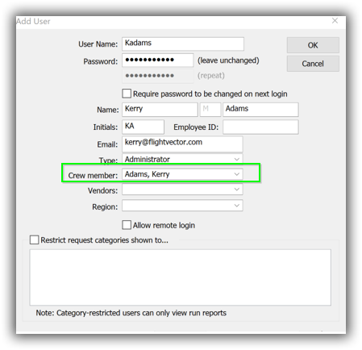
- An Administrator can go to Settings > Users and add the user’s information. A crew member must be selected for access to the crew app.
Figure 7: Add User
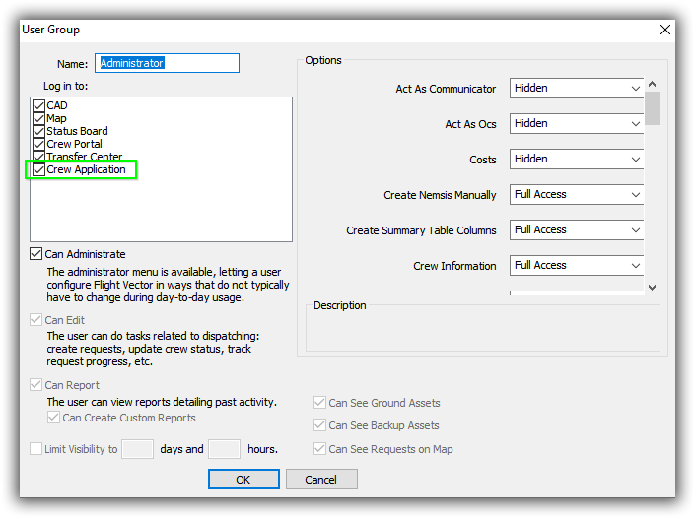
- The user type must have crew app permissions granted (Settings > User Groups).
Figure 8: User Group

Device Registration

There is a setting called Mobile Devices Must Register. If this setting is set to ON, mobile devices attempting to use the crew application must register and be approved by an Administrator. In this situation, the user will receive a message when signing in for the first time.
Figure 9: User Approval Notice

Device Approval and Registration

A CAD Administrator will need to approve the device by going to Settings > Register Devices before the user can access the app through their device.

The user will need to provide the CAD Administrator the device identification.

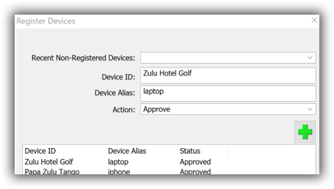
The Administrator will select the Device ID from the Recent Non-Registered Devices drop-down menu, add an Alias name (if desired), select Approve in the Action drop-down, and click the green plus button.
Figure 10: Register Devices
Note: If Mobile Devices Must Register is set to OFF, the device does not need to be registered and this step can be ignored.

Crew App Settings
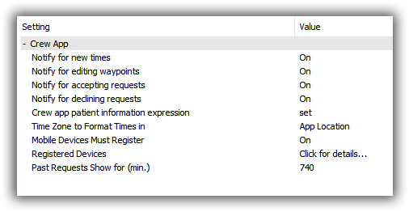
The following settings control various crew app functions.
Figure 11: Crew App Settings

Notify for New Times
Will post notifications in the CAD for time entries entered in the Crew app when turned ON.

Notify for Editing Waypoints
Will post notification in the CAD when waypoints are edited by the Crew App user when ON.

Notify for Accepting Requests
Will post a notification in the CAD when the Crew App user accepts a request when ON.

Notify for Declining Requests
Will post a notification in the CAD when the Crew App user declines a request when ON>

Crew App Patient Information Expression
This expression will be run on a request to return information about the request and its patient(s)/escort(s) to the crew app user. This information will be displayed on the Active Request screen.

Time Zone to Format Times in
Allows the Administrator to determine which time zone the crew app times are formatted. The options are Base or App Location.

Mobile Devices Must Register
Refer to Device Registration.

Registered Devices
Refer to Device Registration.

Past Requests Show for (min.)
Past requests will not be visible from the app after this amount of time. NOTE: Is a particular user group’s visibility (Settings > User Groups) is set to a smaller number than this, past requests will be removed from the application at that time for users belonging to that group.

Crew App Permissions
Each crew action may be controlled by a permission through the CAD UI, by going to Settings > User Groups. The following outlines the permissions and the corresponding Crew app actions.

Crew Members

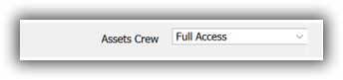
Crew Members on the home, arrive, and depart screens are controlled by the Assets Crew permission and allows a user to add/edit an asset’s active and pending crew. This can inherit from the Asset Editor permission.
Figure 12: Assets Crew
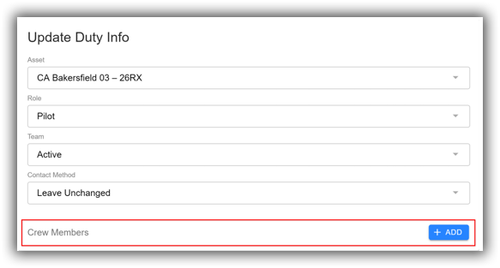
Figure 13: Update Duty Info

Asset Status

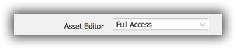
Asset Status information is controlled by the Asset Editor permission. This includes the asset details, conditional statuses, and out of service events.
Figure 14: Asset Editor Permission
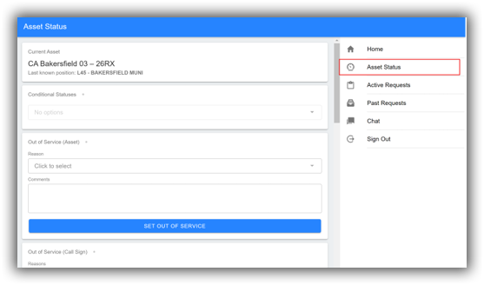
Figure 15: Asset Status Information

Post Location

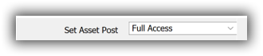
Post Location is controlled by the Set Asset Post permission and allows a user to set the post location for an asset. This can inherit from the Asset Editor permission.
Figure 16: Set Asset Post Permission
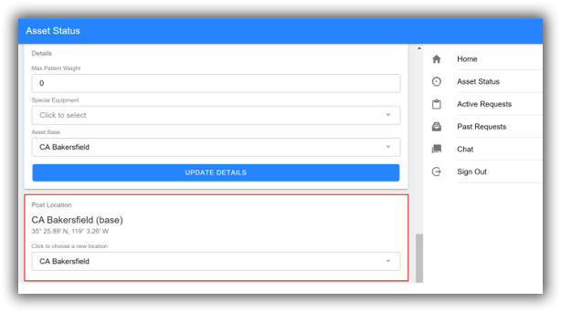
Figure 17: Post Location

Geolocation

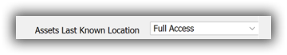
Geolocation is controlled by the Asset’s Last Known Location permission and allows a user to reset an assets last known location. This can inherit from the Asset Editor permission.
Figure 18: Asset's Last Known Location Permission
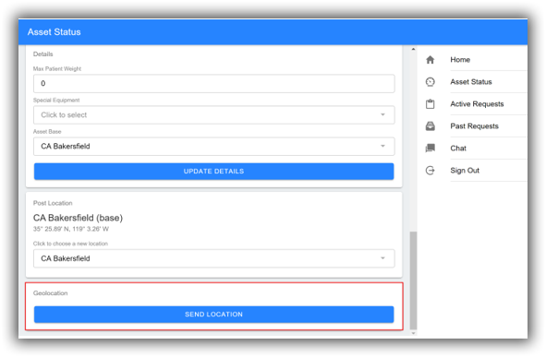
Figure 19: Geolocation

Arriving and Departing Waypoints

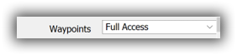
Arriving and Departing Waypoints on active requests are controlled by the Waypoints permission and allows a user to edit the status of waypoints, including arriving and departing.
Figure 20: Waypoints Permission
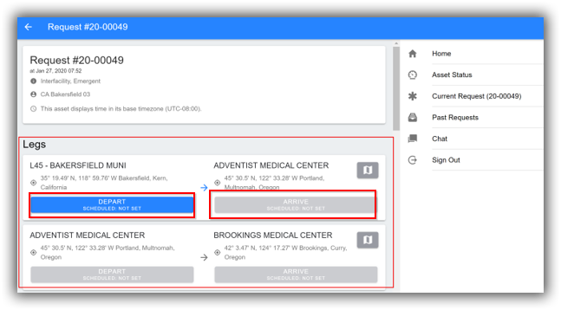
Figure 21: Arriving and Departing Waypoints

Request Time Entries

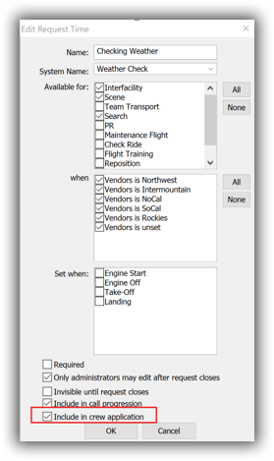
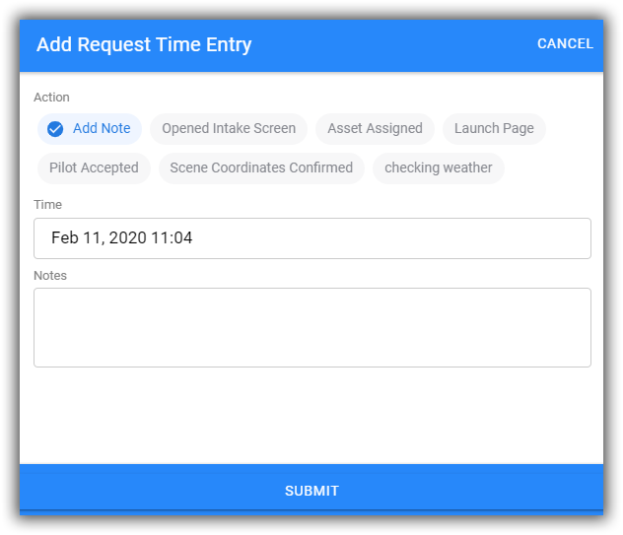
Request Time Entries are controlled by going to Settings > Request Times, selecting the desired time, and checking the box to Include in Crew Application. If checked, the times will be displayed in the application.
Figure 22: Edit Request Time

Patient/Escort Time Entries

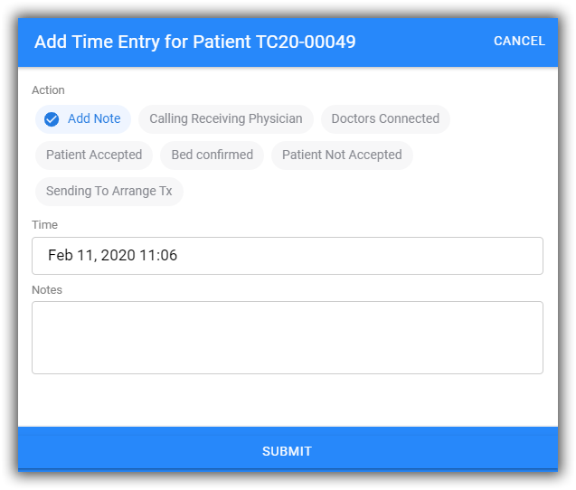
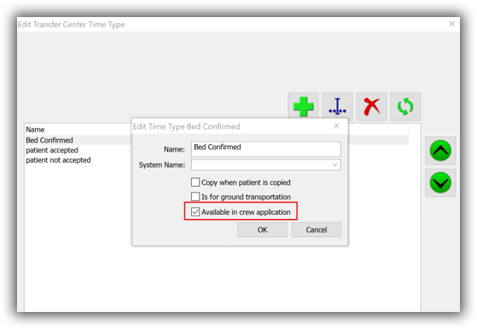
Patient/Escort Times are controlled by going to Settings > Transfer Center Times/Escort Times, selecting the desired time, and checking the box for Available in Crew Application.
Figure 23: Transfer Center/Escort Times

Past Requests

Past Requests are controlled by the Past Requests permission and allows the user to edit past requests.
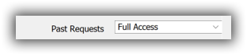
Note: See Crew App Settings above for visibility settings in Past Requests.
Figure 24: Past Requests Permission
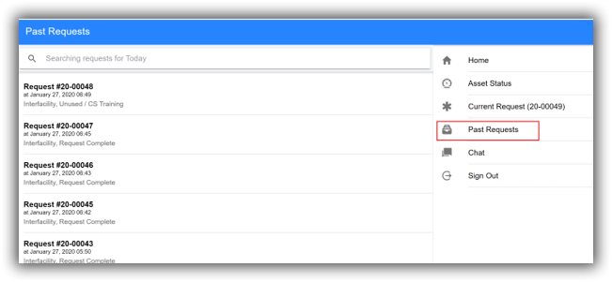
Figure 25: Past Requests

Chat

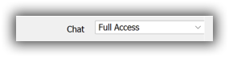
Chats are controlled by the Chat permission.
Figure 26: Chat Permission
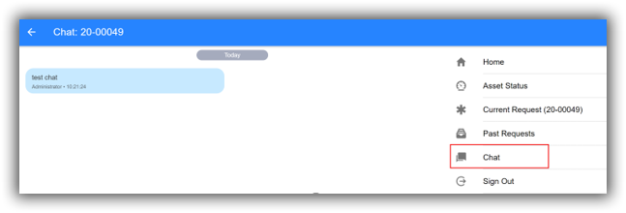
Figure 27: Chat Information

FVCrew Login and Usage

New User Sign-in
- Enter the Login information.
  - Username
  - Password
  - Server
  - Proxy URL
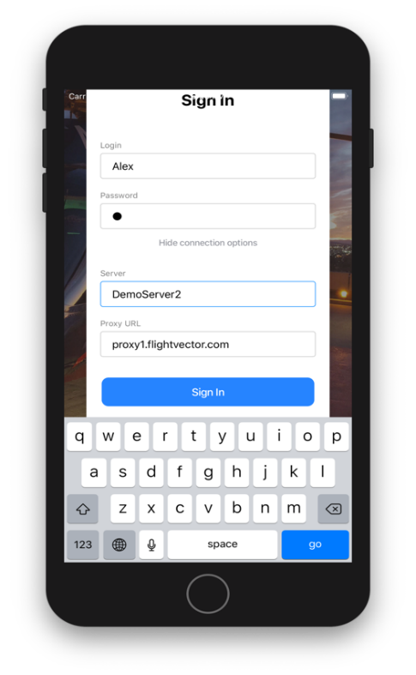
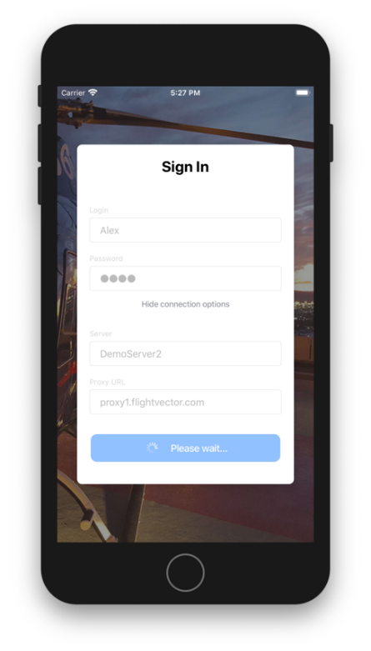
Note: After the initial sign in, the connection options will be hidden from view and user will only need to enter the login and password.
Figure 1: Initial Sign-In
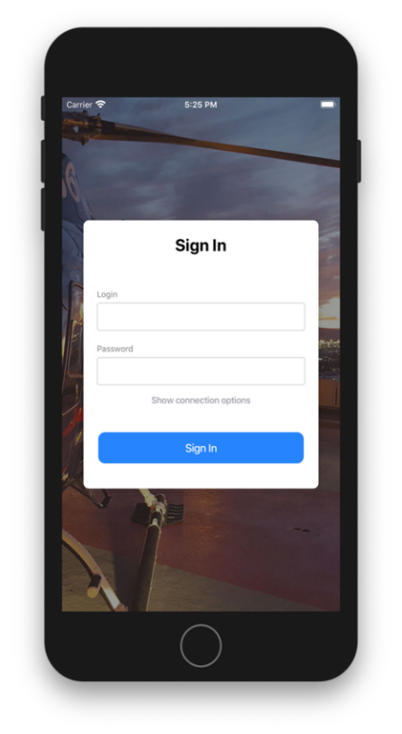
Note: If the user enters an incorrect username or password an error message will be displayed.
Figure 2: Regular Sign-In
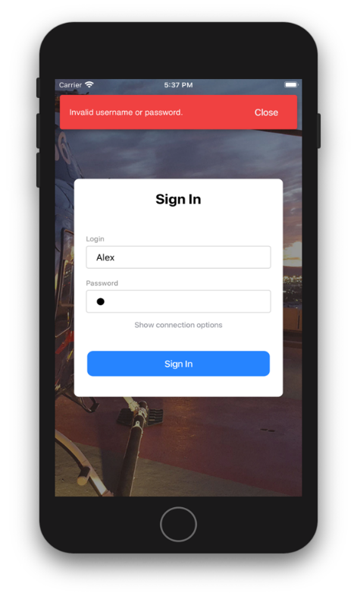
Figure 3: Sign-In Error

Note: If the user sees this message when signing in, they will need to contact a CAD Administrator for device approval.
Figure 4: Approval Error

Setting User PIN after Login
Upon Signing in users are asked to record a 4-digit PIN. Every time a user logs in they will be asked to re-enter their PIN.
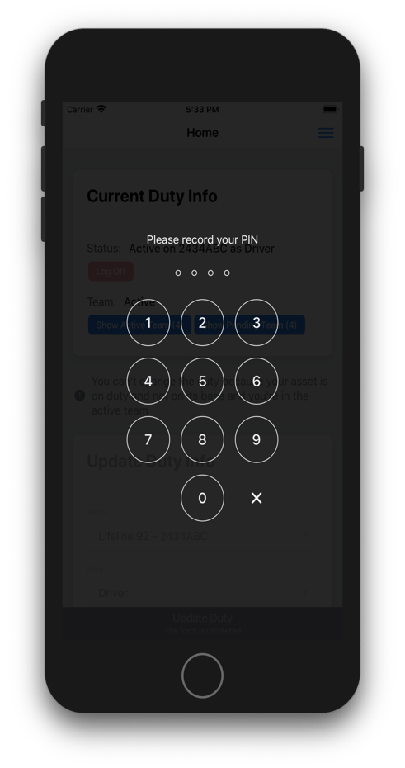
Note: If the PIN is forgotten, click “Forgot your pin?”, then follow the prompts to set a new PIN .
Figure 5: Record PIN
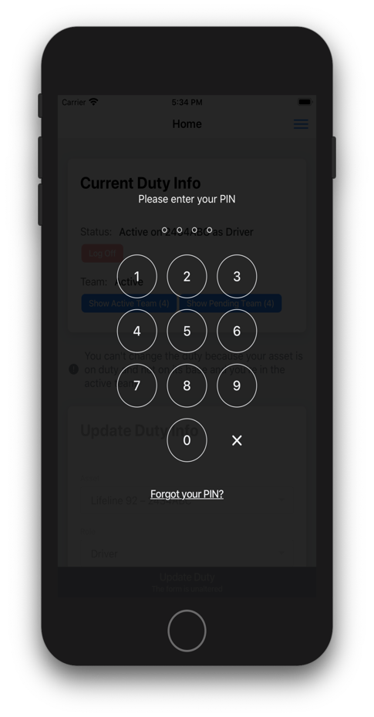
Figure 6: Forgot your PIN?

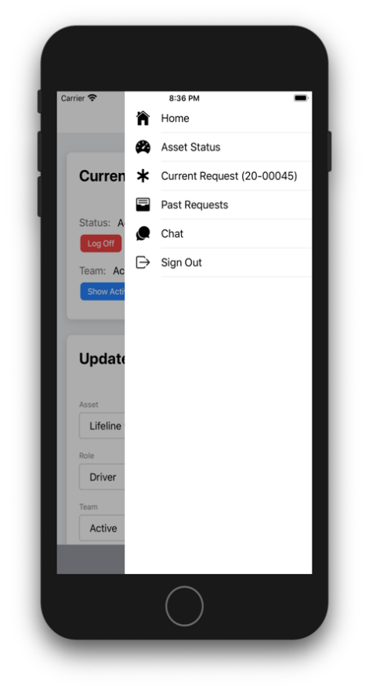
Menu Items
Figure 28: Menu

Home screen
The home screen will display current asset and crew information. User may make crew changes from this screen as well.

Current Duty Info

Status
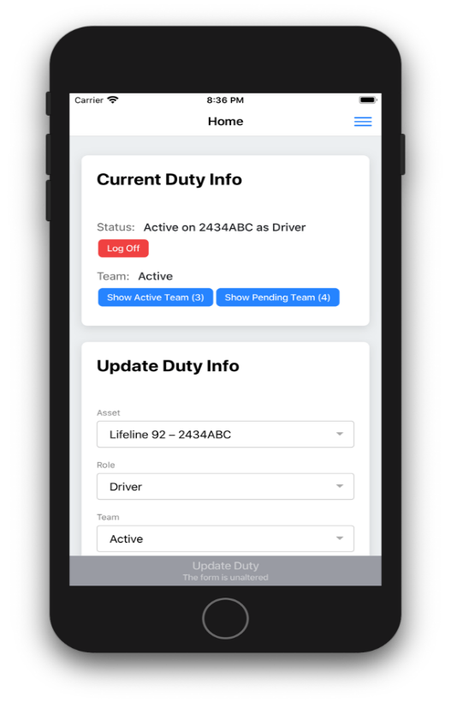
Current asset and current role.
Figure 29: Status

Team
This display shows if the user’s current team is in an Active or Pending state.
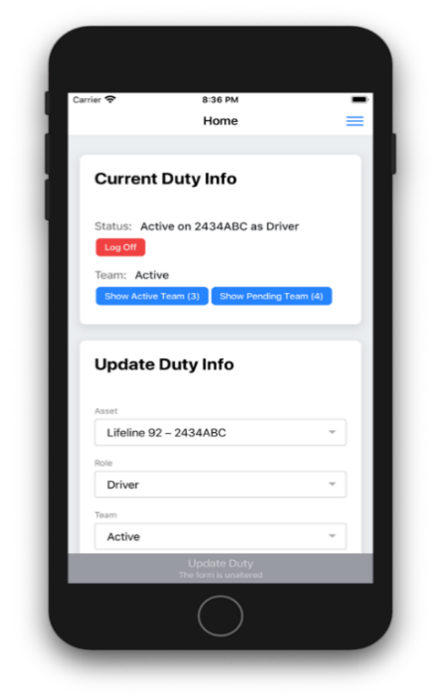
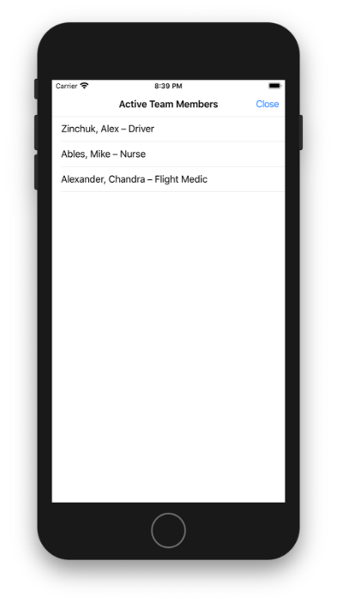
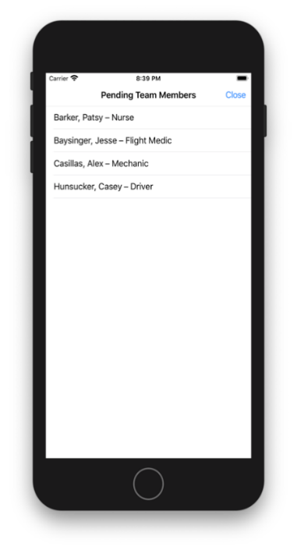
Note: Users also have access to two buttons Show Active Team and/or Show Pending Team. These dialogs are for informational purposes only and cannot be edited.
Figure 30: Active or Pending

Log Off
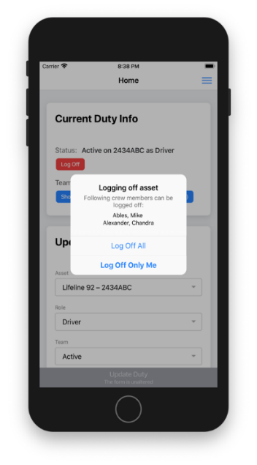
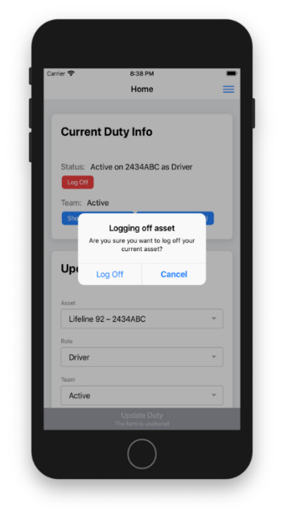
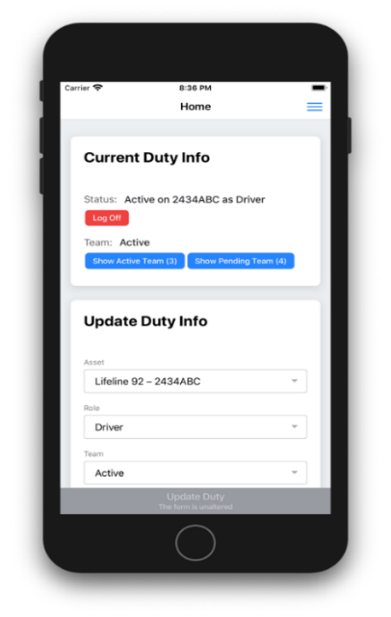
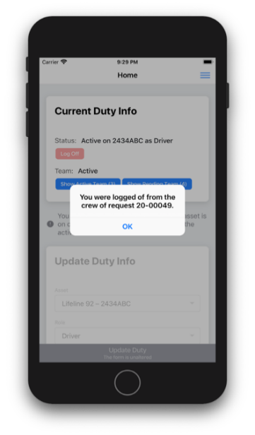
User may remove themselves from the asset by logging off the current asset. Clicking Log Off will allow them to remove themselves and/or other crew members from the asset.
Figure 31: Logging Off

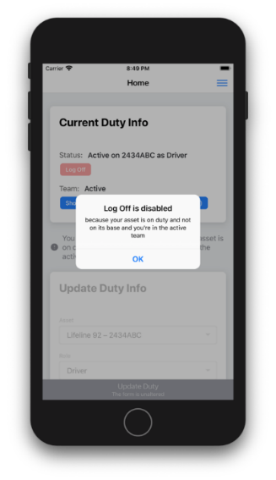
Note: If an asset is currently on duty and not at base, Log Off will be disabled.
Figure 32: Log Off Disabled

Update Duty Info
From this screen the user can update the asset they are on, the role they have, the team status, and/or the contact method.

Asset
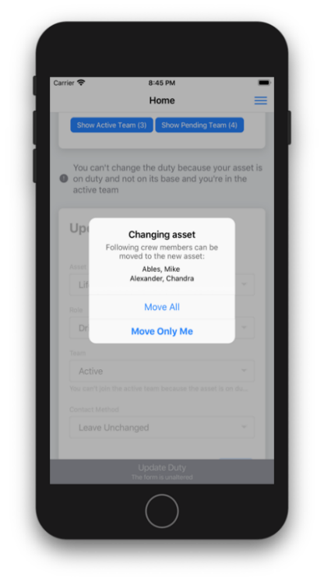
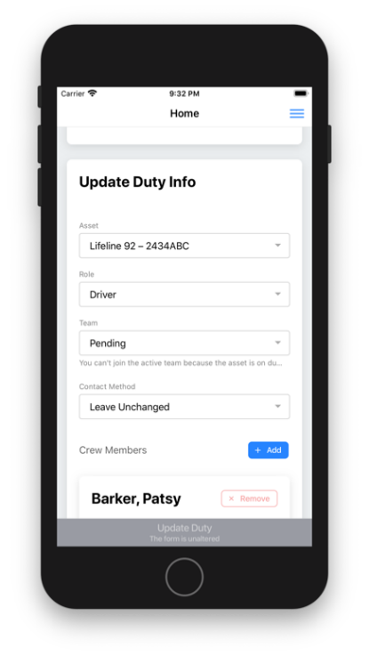
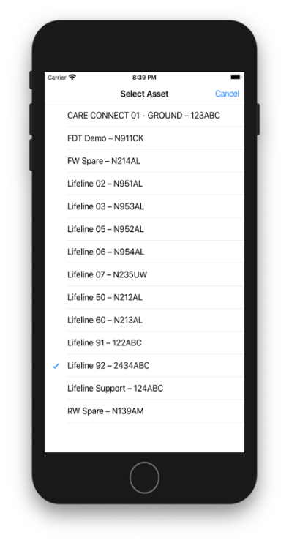
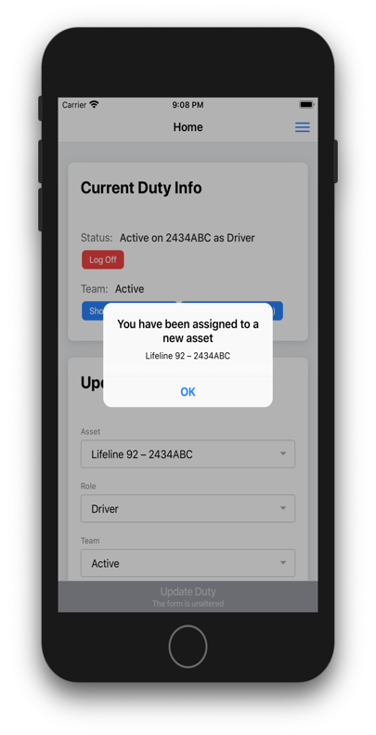
Users may select an asset to be assigned to.
Figure 33: Selecting Asset Flowchart

Role
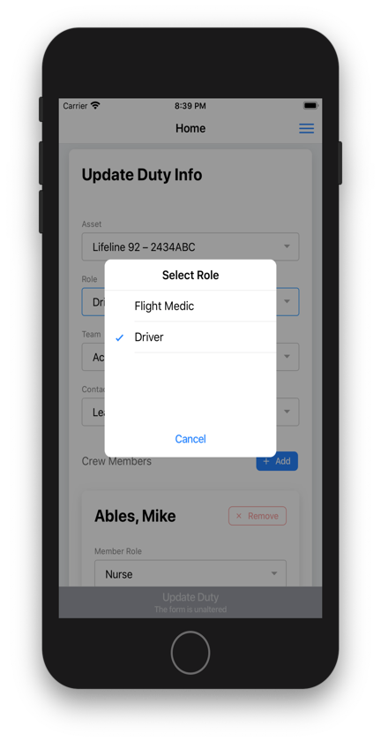
Users may select a role for themselves and each assigned crew member.
Figure 34: Assigning Roles

Team
Users may select if the team is Active or Pending.
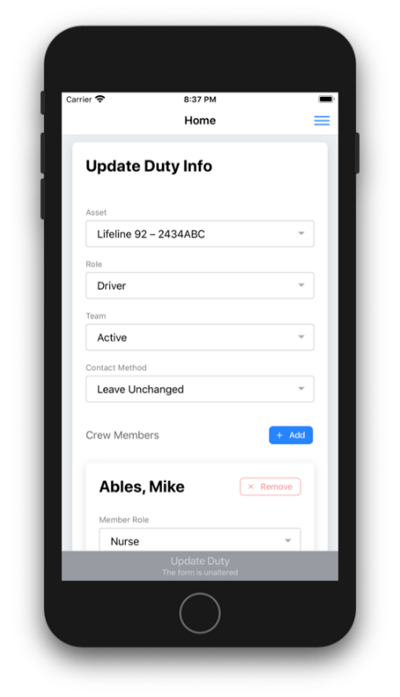
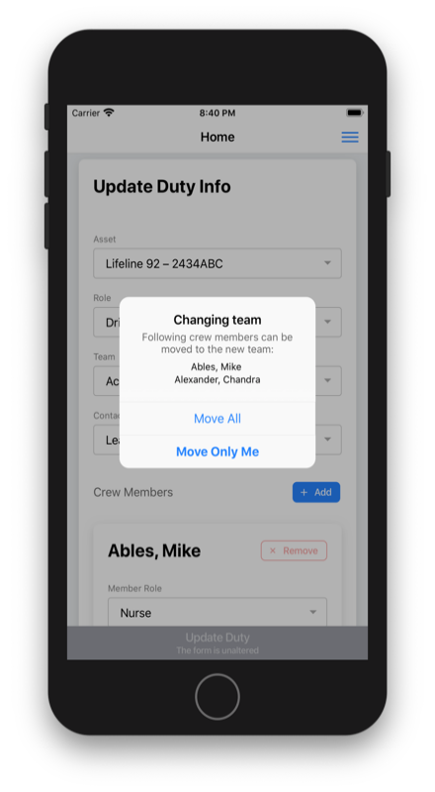
Note: Users may not set the team to active if the asset is not at base.
Figure 35: Update Team Status

Contact Method
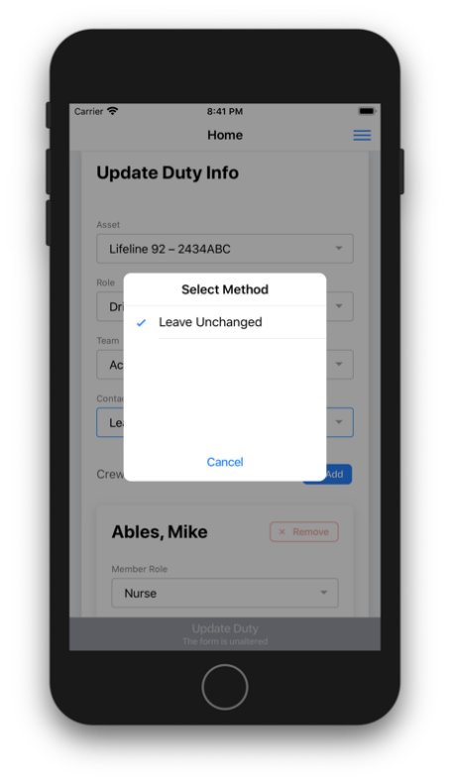
Users may select the contact method.
Figure 36: Contact Method

Asset Status
With permission enabled, users can update conditional statuses, set assets out of service, add asset delay times, update asset details, and set the assets post location or send geolocation of the app user.

Current Asset
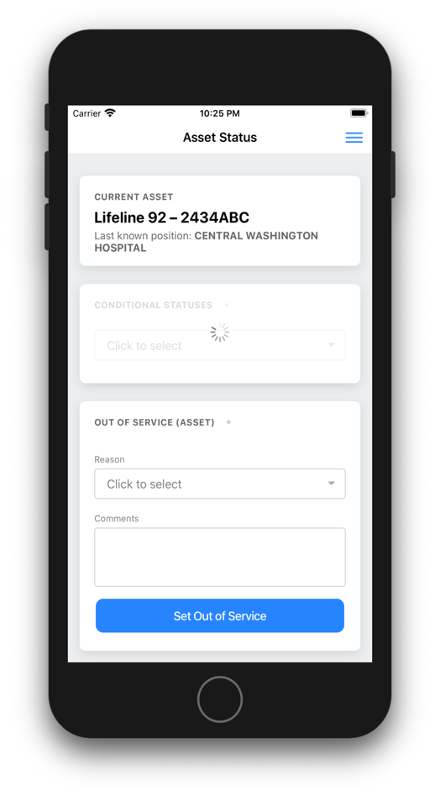
Current Asset will display the Callsign, Asset Number, and the Last Known Position.
Figure 37: Current Asset

Conditional Statuses
Users may select/unselect conditional statuses for their asset.
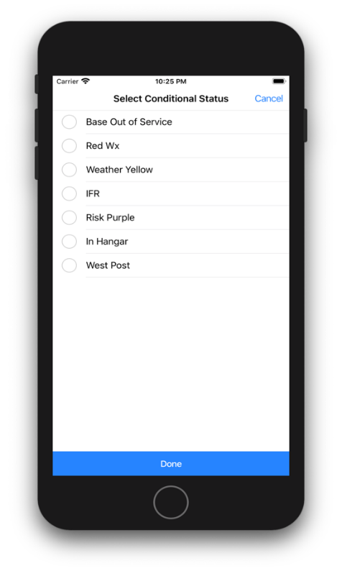
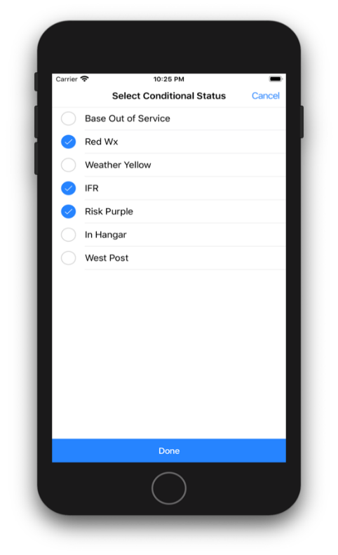
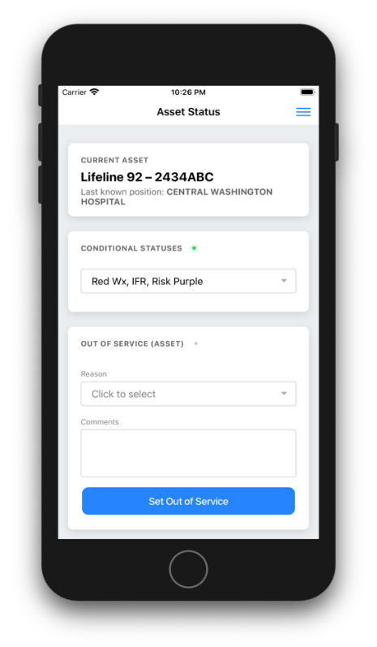
Note: When a conditional status exists, a green-dot indicator is present.
Figure 38: Conditional Statuses

Out of Service (Asset)
Users may set an asset out of service by selecting a reason from a pre-defined list of assets out of service reasons. Optionally, they may add a comment when adding an out of service reason. Users may return the asset to service by selecting Set Back to Service.
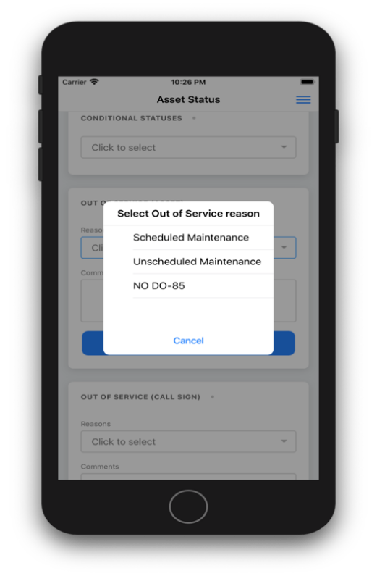
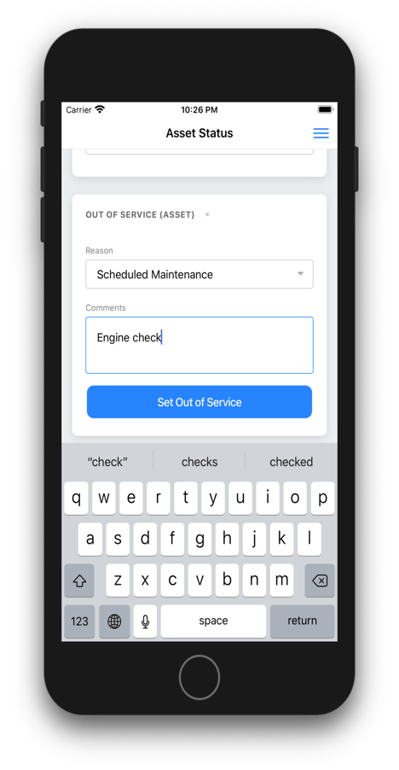
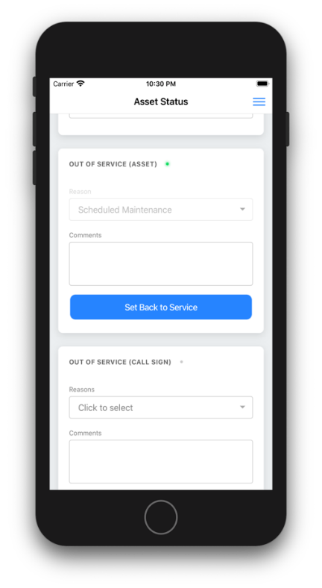
Note: When an asset is out of service, a green-dot indicator is present.
Figure 39: Set to Out of Service

Out of Service (Call Sign)
Users may set a Call Sign out of service by selecting a reason from a pre-defined list of call sign out of service reasons. Optionally, they may add a comment when adding an out of service reason. Users may return the Call Sign to service by selecting Set Back to Service.
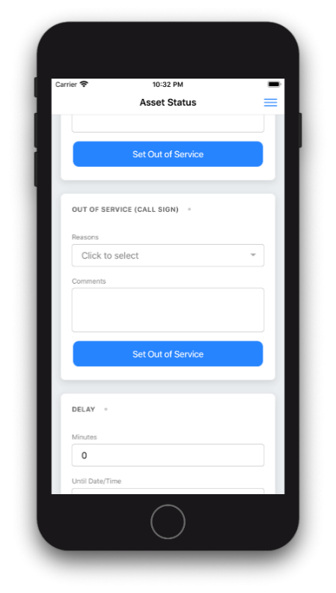
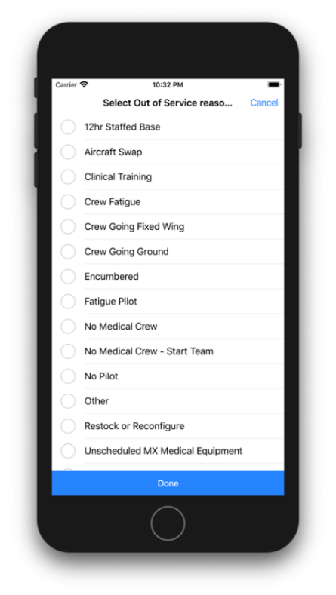
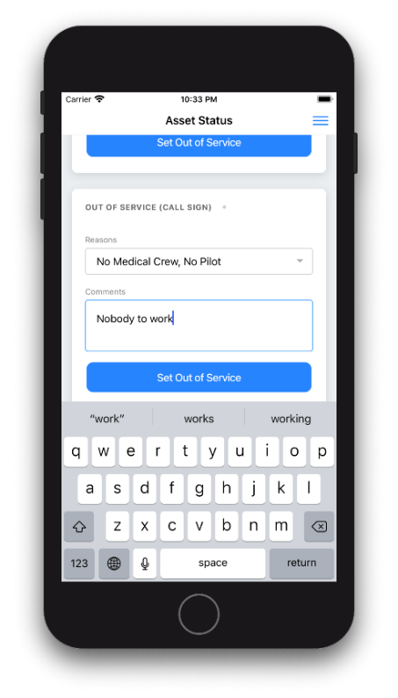
Note: When a call-sign is out of service, a green-dot indicator is present.
Figure 40: Out of Service Call Sign

Delay
Users may add a delay (in minutes) to their asset or remove a delay. They may optionally add an end time to the delay.
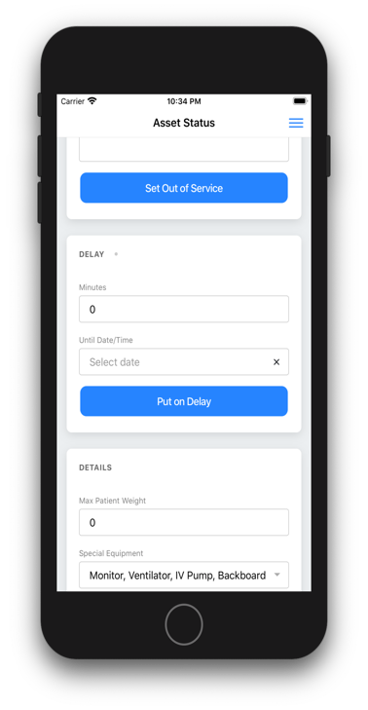
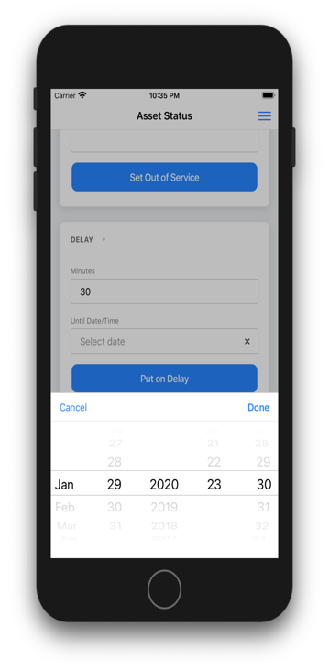
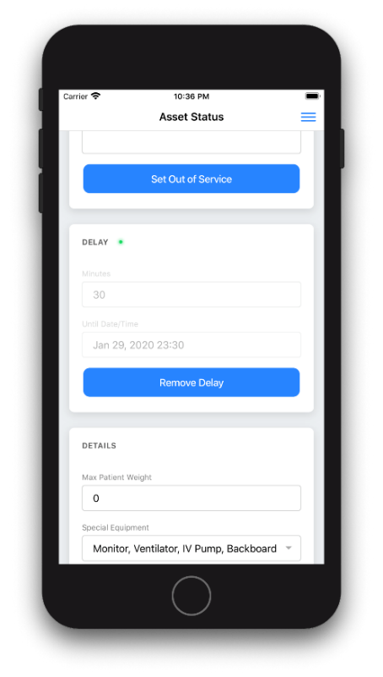
Note: When a delay is present, a green-dot indicator is present.
Figure 41: Setting an Asset Delay

Details
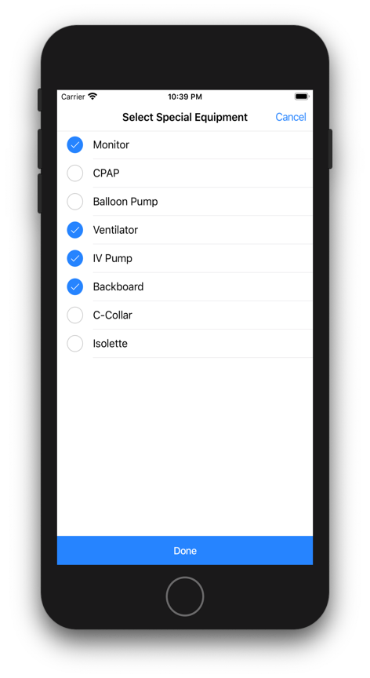
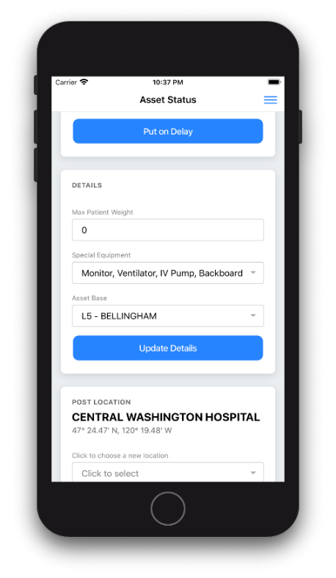
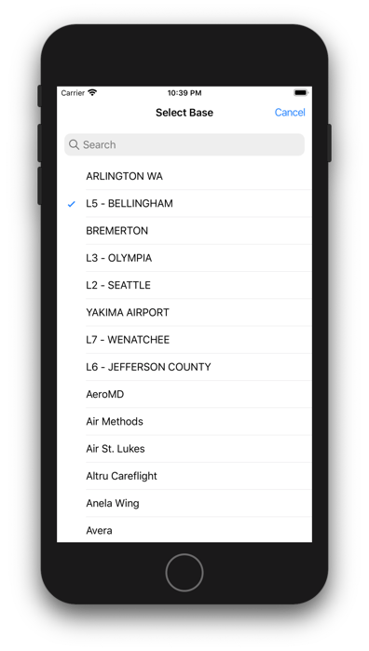
User may add asset details that include Max Patient Weight, Special Equipment Capabilities, and Asset Base information.
Figure 42: Asset Status Details

Post Location
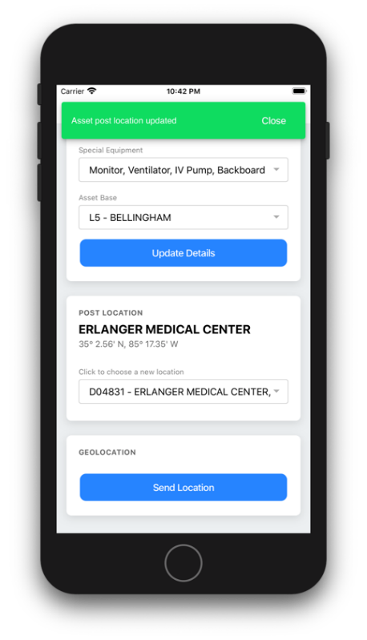
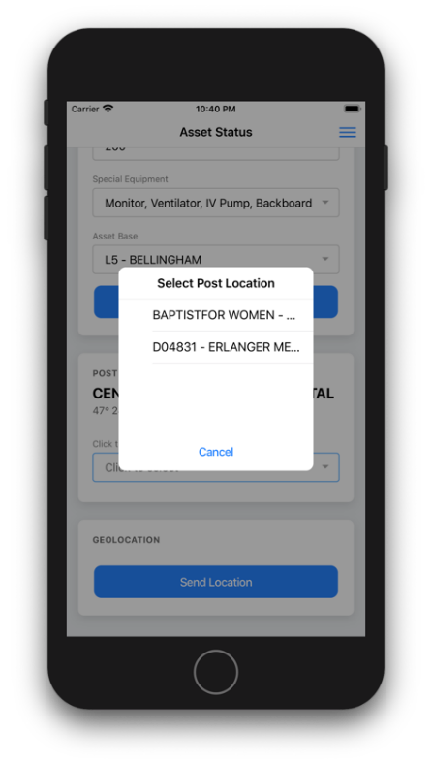
Users may select an asset post location from a pre-defined list of post locations.
Figure 43: Post Location

Geolocation
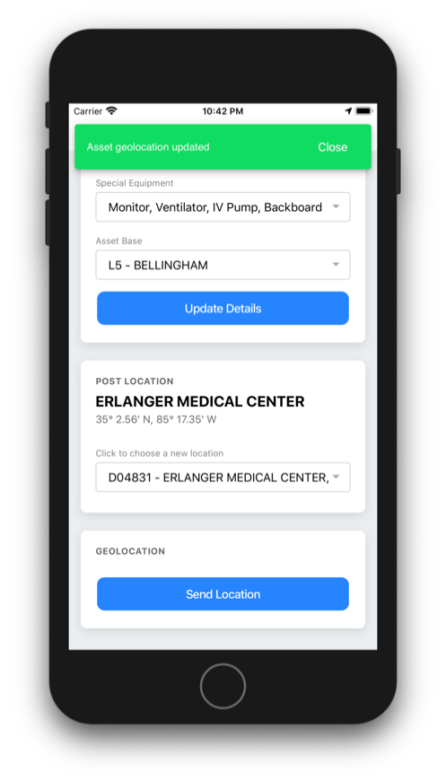
Users may set the asset position by sending the geolocation from the Crew App.
Figure 44: Geolocation

Current Request
The Current Request screen shows the user a list of current assigned request. Selecting a request from the list will display the Request information, Legs, Time Entries, and Event Log.
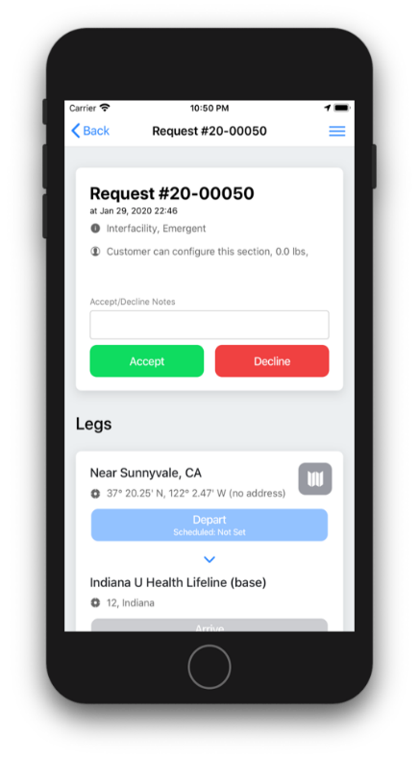
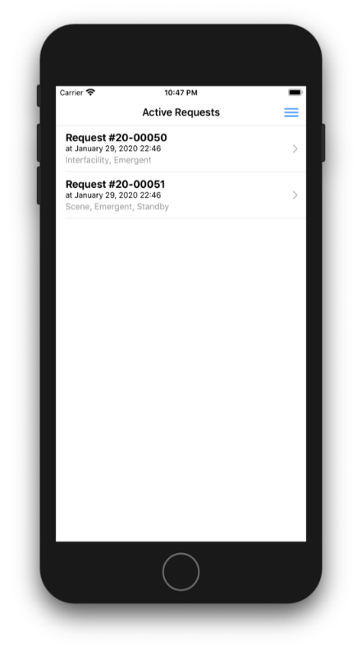
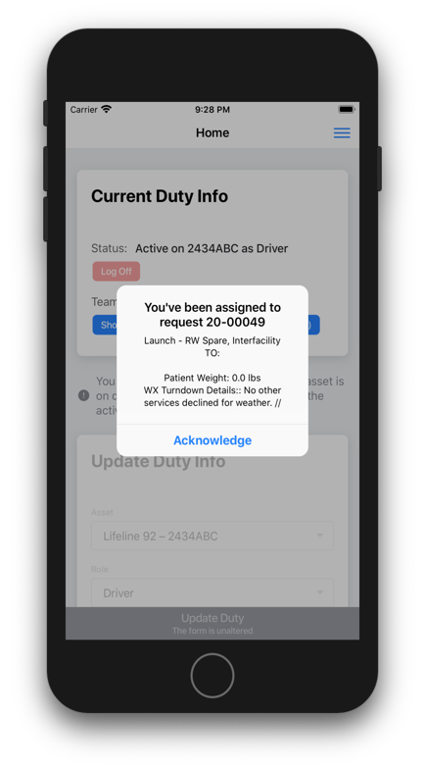
When assigned to a new request, an acknowledgement pop-up will appear. This pop-up will include launch/stand-by/weather check page information for user acknowledgement. This will continue to alert the user until acknowledgment is made.
Figure 45: Current Request

Request Information
This information will include the request number, call type and priority. Additionally, users can accept or decline the request, with the option to add notes.
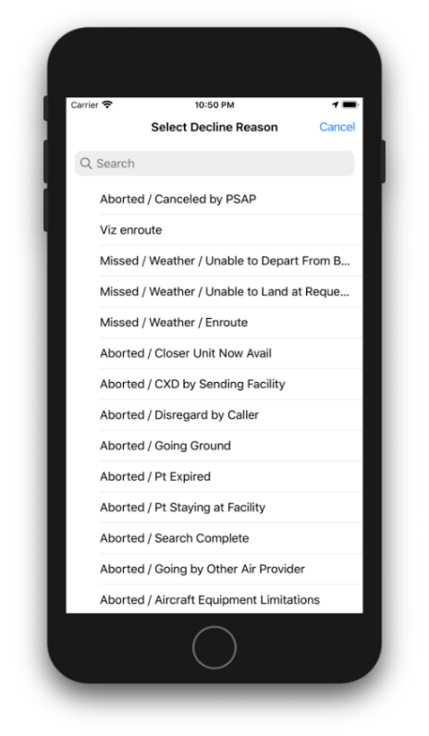
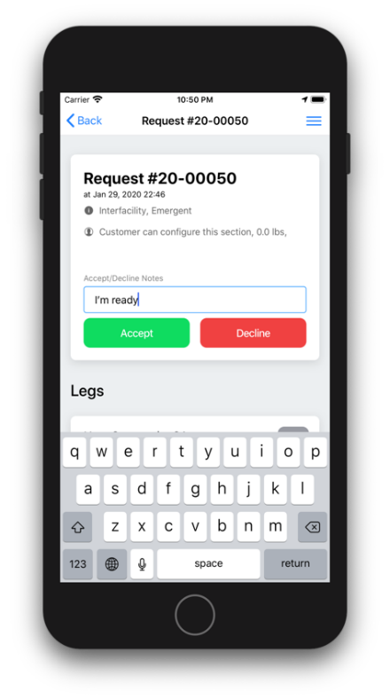
Note: When declining, a user will get a pre-defined list of reasons for declined, and the asset will be removed from the request.
Figure 46: Request Information

Legs
Leg will display each leg of the request. Users may depart and arrive waypoints for each leg. Upon Departing or Arriving, users will be able to provide relevant information.
Additionally, a map button will be displayed for each leg. This button will provide a map and give the user the option to Open Directions.
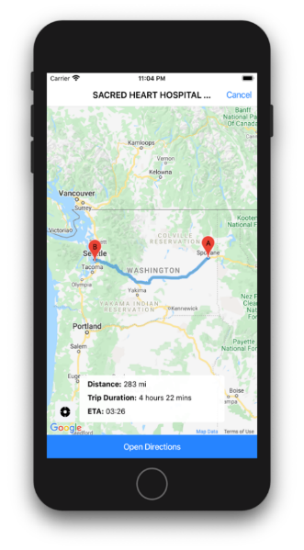
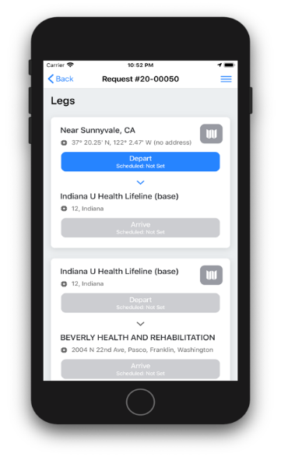
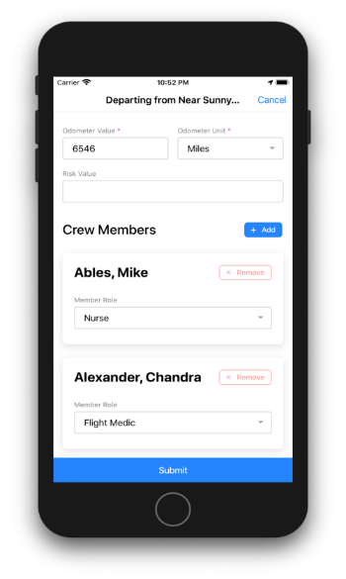
Note: If needed, the user may un-arrive or un-depart by simply clicking the button again.
Figure 47: Legs

Time Entries
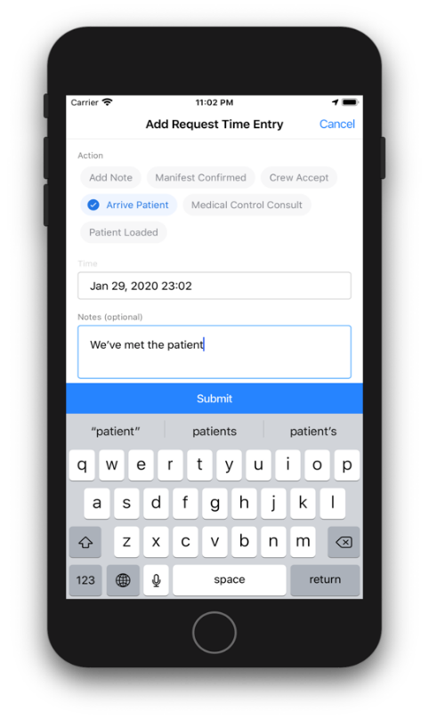
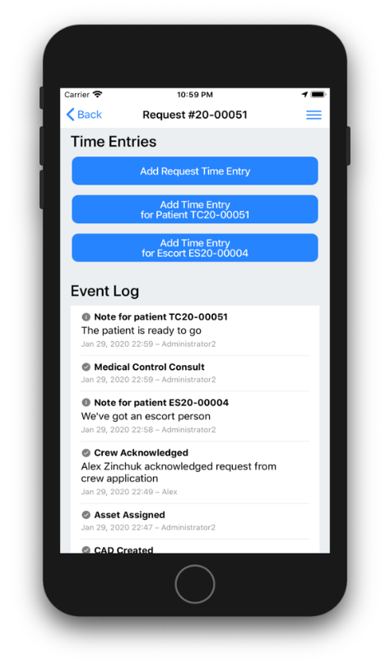
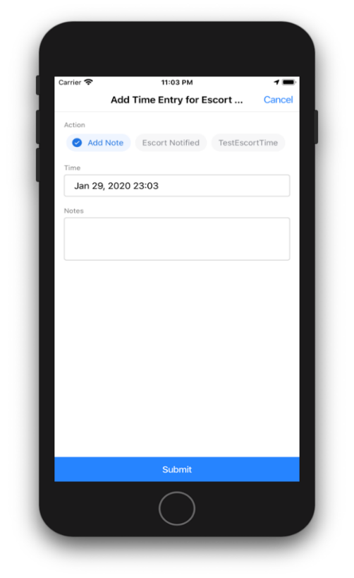
This section will allow users to add request and/or patient/escort times to the request.
Figure 48: Time Entries

Event Log
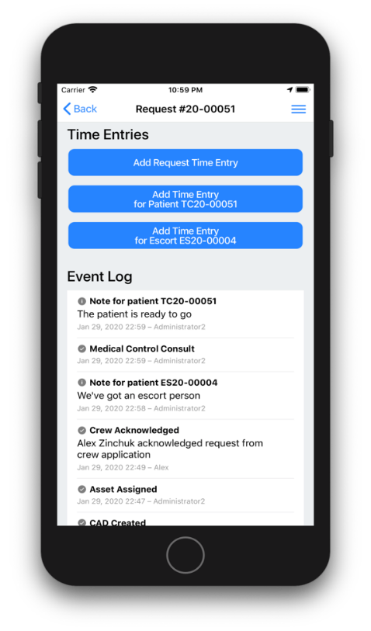
The event log is a recorded history of the app and request interactions.
Figure 49: Event Log

Past Requests
Users can search past requests by selecting filters on the search requests screen. A list of request results will be displayed. Users can expand the desired request by clicking on it to display more information.
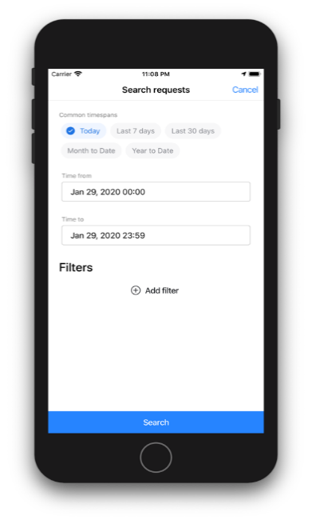
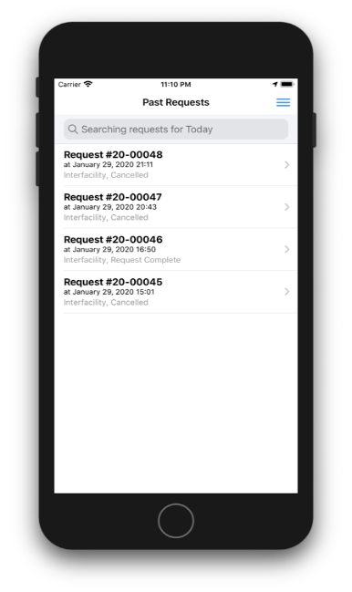
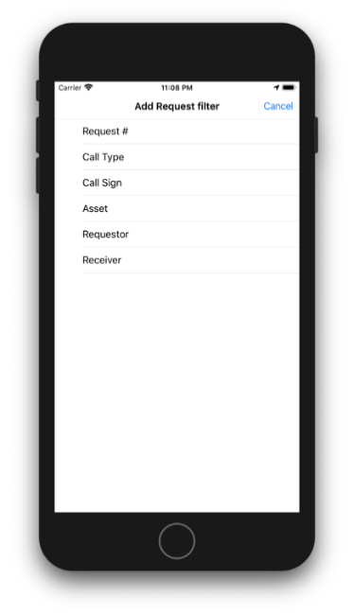
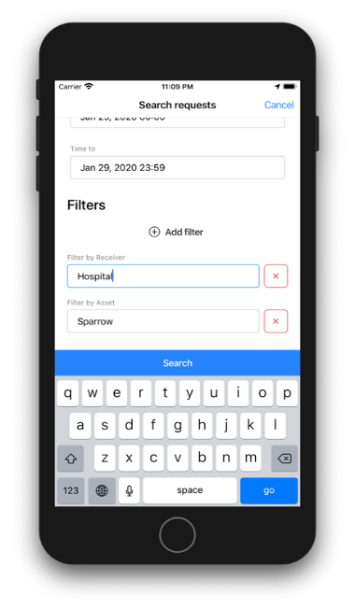
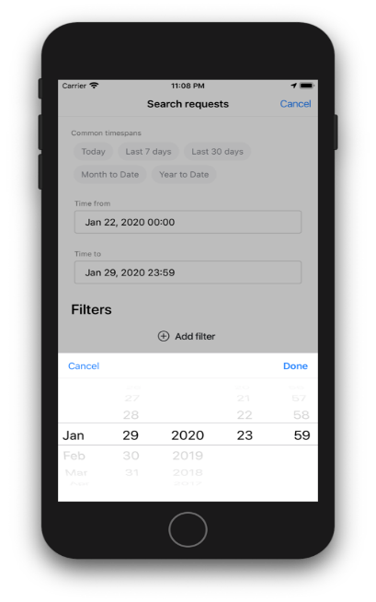
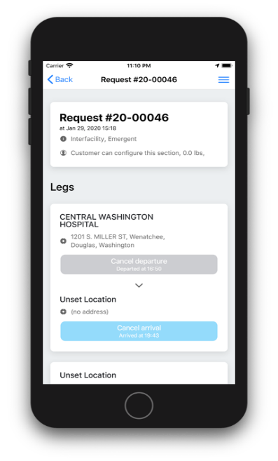
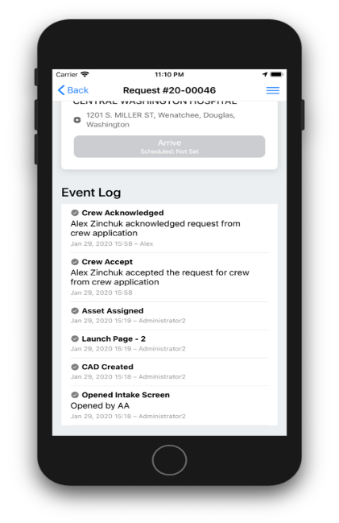
Note: Past requests are informational only and may not be edited.
Figure 50: Searching Past Requests

Chat
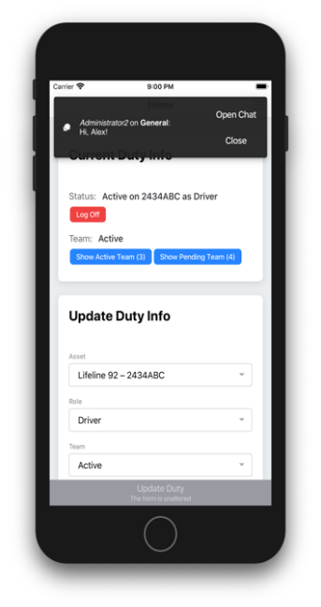
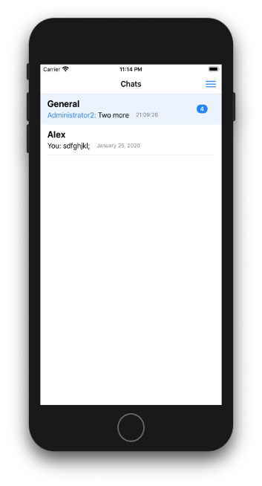
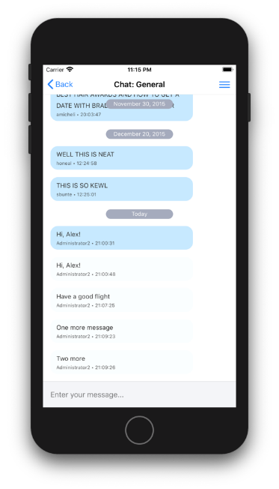
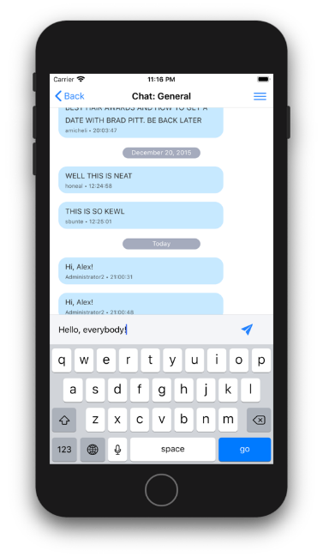
Users can chat with CAD users regarding the current request(s).
Figure 51: Chat

Sign out
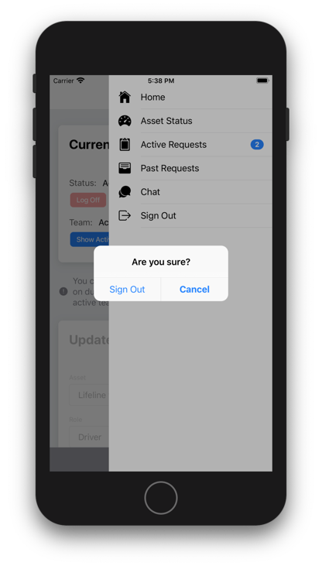
Clicking sign out will ask the user if they are sure if they want to sign out. They can click Sign out or cancel. Sign out takes them to the Sign In screen. And cancel returns them to the previous crew app screen.
Figure 52: Sign Out

